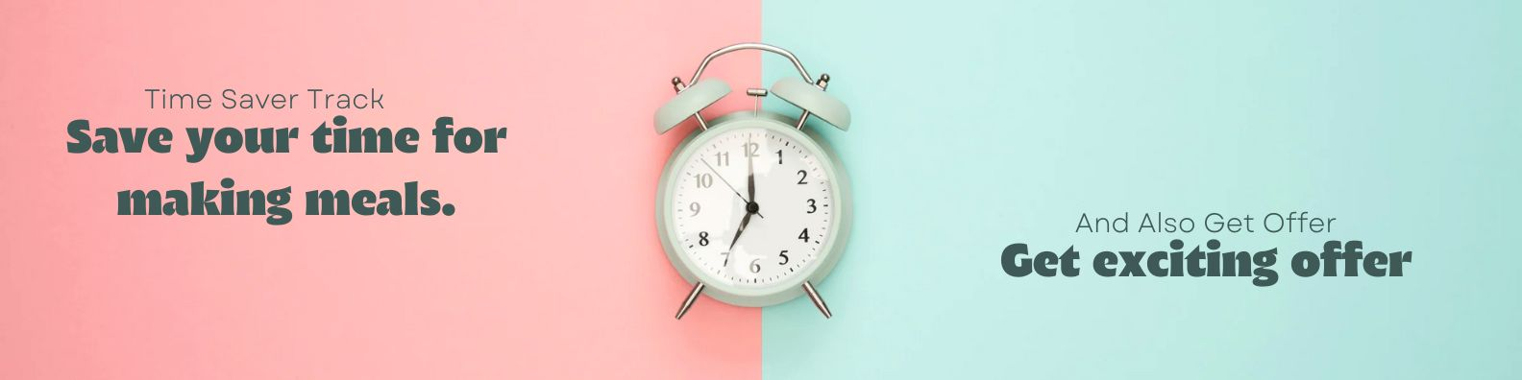

**[PRD]**

**Time Saver Tracker and Offer**

| Title/Initiative | Time Saver Tracker and Offer |
| --- | --- |
| Date & Version | 08-10-2024 |
| Product - Point of  Contact (POC) | Om Patel |
| Design POC |  |
| Tech POC |  |
| Marketing POC |  |

**Why? (Objective)**

1. For business.

* Increase in order counts, generating more revenue by user retention

2. For users.

* Keeping track of time saved by using MonkeyBox Services
* Rewards at the end of ## Hours of time savings or as planned
* Personalized feel of MB service

**How do we measure success?**

1. Associated OKR/Goal - Encourage users to fill time tracker

2. Success Metrics - reward received or completion of 1 time strip

**Who are the users:**

1. Persona

* Pooja uses the MB service whenever she is out of town, most of the time making food for her kid by herself.
* She is a working mother and goes to work after this routine every day.
* We can remind her of the total time saved and can use that anywhere else.

2. Problems we are solving

* Needs - to make them feel like worth using the service
* Problem - no such tracker to count the frequency of usage and reward loyal users more frequently

3. How do we know these problems exist (xto10x Report)

* Using MonkeyBox only when parents feel like taking a break or are not able to make it for the upcoming few days or just once in a while variety of options for kids

**Solution:**

**1. Brief of the solution**.

* We will introduce a Time Saver Tracker in the MonkeyBox app to monitor the total time users save by opting for our services instead of preparing themselves.
* The tracker will have a visual representation, updating based on usage. Once a user reaches specific time-saving milestones (e.g., 10 hours saved), they will be rewarded with discounts, exclusive offers, or loyalty perks. This encourages continued use and fosters a personalized connection to the service.
* Rewards will reinforce the value users gain from the service, especially Loyal user
* Sharing of time saved achievements for social media stories and status

**2. Other alternatives are considered with prioritization metrics.**

* **Usage-based Discount System**
* Description: Users receive discounts based on the number of orders placed, rather than tracking time saved.
* Pros: Easier to implement, clear incentive for frequent users.
* Cons: Lacks personalization and do not focus on time saved, which is a key value driver for working parents as well as MB Mission.
* Prioritization: Medium - Provides value but doesn’t emphasize the unique benefit of MonkeyBox in terms of convenience and time savings.

**Product flow (Details of the feature/product):**

A. Customer Journey

**1. Awareness Phase**

* **Trigger**: Pooja, a working mother, sees a notification or marketing communication from MonkeyBox about the new "Time Saver Tracker" feature and its associated rewards for loyal users.
* **Action**: She opens the app to learn more about how the feature works, understanding that it tracks the time she saves by ordering meals instead of preparing by herself.
* **Emotion**: Curious and interested in seeing how much time she’s saving and what rewards she can earn.

**2. Usage Phase**

* **Trigger**: Pooja places an order for her child’s meal and the tracker updates, displaying the amount of time saved. Each time she uses MonkeyBox, the tracker continues to log saved hours.
* **Action**: She keeps checking the tracker to see her progress towards the next reward milestone, receiving notifications with her accumulated hours and potential rewards (e.g., discounts, and offers).
* **Emotion**: Satisfied with the visible benefits of time-saving, motivated to continue using the service as she feels a tangible value from not having to prepare meals.

**3. Reward and Engagement**

* **Trigger**: After saving a total of 10 hours, Pooja receives a push notification informing her that she has unlocked a reward (e.g., Coupon amount received in wallet worth 1 order).
* **Action**: Pooja claims her reward through the app and uses it on her next order. The tracker resets and begins counting again towards the next milestone.
* **Emotion**: Excited and appreciated, as she feels recognized for her continued use of the service. The reward also strengthens her loyalty to MonkeyBox.

**4. Referral and Sharing**

* **Trigger**: Pooja sees an option to share her total saved time and rewards with her friends via social media or messaging apps.
* **Action**: She shares her progress, encouraging her friends (other parents) to try the service and benefit from the time-saving feature.
* **Emotion**: Proud of her achievement and eager to let others know about the convenience and rewards offered by MonkeyBox.

**5. Retention and Long-term Engagement**

* **Trigger**: As Pooja continues to save time with MonkeyBox, the tracker offers new rewards at different milestones (e.g., 20, 30 hours saved), keeping her engaged.
* **Action**: she remains a loyal and satisfied customer.
* **Emotion**: Loyal and connected, appreciating the time she’s saving and the continuous rewards, which further enhance her experience with MonkeyBox.

2. Wireframes and Flow diagrams

3. User Stories

4. User acceptance criteria

5. Edge cases

6. Event tracking sheet

* Existing Events to be used
  + Order Placed (Backend)
  + Auto Order placed (Backend)
* New Events needs to be created
  + Time strip completion

**Tentative Timelines:**

| Task | Date |
| --- | --- |
| Leadership approval | 11/10/2024 |
| Design ready |  |
| Prototype testing |  |
| Development starts |  |
| Beta Launch |  |

**Dependencies:**

1. Open Questions

2. Infrastructure requirements

3. Budget approvals

4. Partner Support (APIs, Partnerships)

5. Internal Dependencies (Tech, Design, Other Teams)

**Related documents:**

1. Tech planning document

2. Design planning document

3. Go to market planning